

May 5th, 2017

“Carlos”

Consumer Care Representative

[consumer.care@bordendairy.com](mailto:consumer.care@bordendairy.com)

Borden Dairy

8759 N Central Expy. #400

Dallas , TX 75231

Dear “Carlos”, *Consumer Care Representative:*

As a consumer care representative, you most likely receive some comments that quite frankly, are not true and definitely not well supported with any proof. We value your time and believe that the enclosed report is not a waste of it. We believe that it is supported with enough evidence that it may bring a new thought and hopefully, a change to the way products are packaged at Borden. We are students at Kansas State University - Polytechnic Campus. At K-State we are advocating for the elimination of single-use plastics and reintroduction of reusable containers in modern manufacturing. With these ideas in mind we have written you a Recommendations Report containing our recommendation to you, suggesting that Borden switch its plastic milk jugs, back to glass bottles.

In this report you will find our research regarding the current relation between manufacturers, single-use plastics, and our world’s environment. We will provide you with research about the environmental effects of plastic pollution caused by single-use plastics, as well an environmentally friendly alternative to the milk jug that has already been used and should be brought back to mass production.

We thank you in advance for the time you take to look over our report, and look forward to hearing your thoughts on the subject.

Sincerely,



Austin Kuhlman Trenton Wood



**Recommendations Report**

**To Borden Dairy**

**Research and Writing compiled by:**

**Austin Kuhlman  
Trenton Wood**

Students of ENGL 302 - Technical Writing

Instructor - Ms. Tissa Salter

**Abstract**

If there is a company that understands the amount of milk consumed in the United States, it is Borden. Since the late 1920s Borden has consistently supplied Americans with nutritional and beneficial milk. Things were fine for many years. The local milkman would both distribute the milk on a scheduled basis, and then collect the bottles when the consumers had finished the milk. The milkman would take the bottles to the bottling plant where they would be sterilized for reuse.

Enter the world of single-use plastic. At a glance, plastic seemed to be the ultimate way to change the way milk was distributed. Consumers could elect to get their milk on their own by going to the market where they would buy everything else. When they were finished with the milk, just pitch the jug in the trash, no harm done right? – Wrong.

At Kansas State University, Polytechnic Campus, in our technical writing class, we were challenged to write to a chosen company and have them move away from single-use plastic. We knew that we wanted to target a dairy because milk is something that nearly everyone drinks. It is so routine – wake up and eat a bowl of cereal *with milk,* have lunch and guess what we drink - *milk,* make a meal for supper and every dish contains *milk.* We chose Borden because of the long history as a dairy company which therefore had some experience with glass milk bottles of the past. Another reason is that we believe Borden could lead the pack of large milk producers in the reintroduction of glass bottles.

In this Recommendations Report we propose to Borden that the company switch from using plastic milk jugs to a more environmentally friendly refillable glass milk bottle. You will see just how much waste is being created by plastic milk jugs, the effect of switching to glass to Borden’s image as a company, a common concern with glass bottles, and how the system of reuse is the only truly effective method in eliminating waste.

**How much plastic waste are milk jugs producing?**

The amount of milk consumed in America is truly remarkable. On average, each American drinks 20.4 gallons of milk per year (Huffington Post, 2011). Considering that there are 321.4 million American citizens the amount of milk consumed is a staggering 6.5 billion gallons of milk. The amount of that milk that is bottled in glass today is negligent. Given these numbers and the assumption that each plastic milk jug averages a weight of 60 grams, the amount of plastic waste generated is over 850 million pounds. According to a 2014 EPA report, only 29.5% of this waste is captured and recycled (EPA, 2014, pg. 5). This leaves about 600 million pounds of milk jugs to rot in landfills or worse, in our environment each year.

|  |  |
| --- | --- |
| Top Consumed Beverages in America (Values are per Capita) | |
| Carbonated Soft Drinks | 44.7 gallons |
| Bottles Water | 28.3 gallons |
| Beer | 20.8 gallons |
| Milk | 20.4 gallons |
| Coffee | 18.5 gallons |
| Fruit Beverages | 11.5 gallons |
| Tea | 10.3 gallons |
| Sports Beverages | 4 gallons |
| Wine | 2.3 gallons |
| Value-Added Water | 1.5 gallons |
| Distilled Spirits | 1.5 gallons |
| Energy Drinks | 1.2 gallons |

**Figure 1.**  It is also important to point out that most of the beverages in figure 1 are either packaged in aluminum cans (which people have incentive to collect), bags-in-a-box (poured out of a fountain), in glass bottles, or other, more eco-friendly packaging that is less harmful that plastic milk jugs.

With these figures, I hope that you see that the amount of plastic of plastic being dumped is appalling. Each individual thinks that their 20 milk jugs a year make no difference and to a point they do not; but the fact that so many people feel this way make this an issue worth considering. It is worth pointing out that the consumer is forced to buy what the companies are putting on the shelf. There are more efforts today than in years past to make our planet green again. These efforts tend to fail because producers simply are not providing the consumers with viable options. No matter how much the end user tries to be better in their go-green effort, a lack of a decent recycling infrastructure and the fast-paced society we live in keep them from achieving their goal. Consumers desire to go green prove to be a perfect segue into our next point about the proposed change would affect Borden’s image.

**What would this switch do to our company’s image?**

Switching to glass from plastic generally improves the image of the product and the company that offers it. In the 112th volume of the Dairy Foods Journal, this is pointed out by an example of Stanpac using glass containers for its yogurt. According to the company, its glass packaging shows their “...premium quality and environmental responsibility” (Dairy Foods, 2011, pg 96). We believe that Borden could gain this elite status if you begin to use glass packaging again.

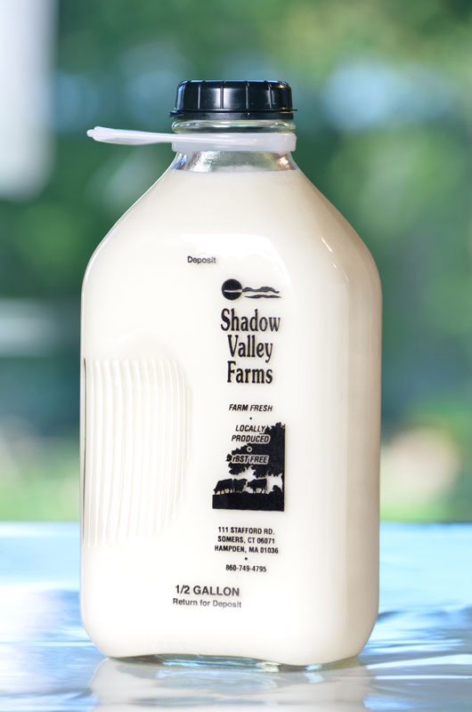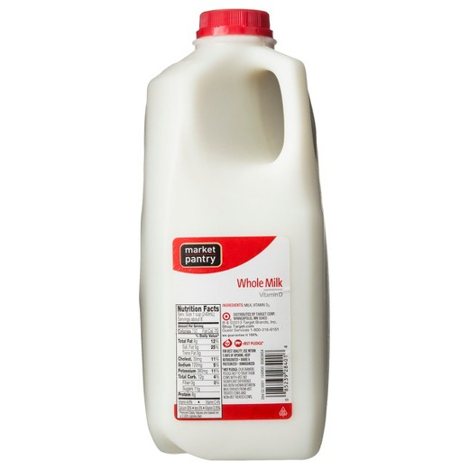

**Figure 2.** It is easy to see that the glass milk bottle has better consumer appeal than that of the plastic milk jug which looks very artificial.

Having an elite image comes at a consequence, yes. That consequence is a larger consumer base and more sales. With more sales there is more profit. We are not denying that the cost of glass is much higher than plastic, but we believe that the increase in profits would cover the added cost of glass. Happy consumers, enjoying a premium product, need only bring back their bottles to the store to receive their deposit. What could be better than this? If Borden takes the steps required to make this change slowly over time, the consumers will get used to the idea of getting their milk in glass. Once the consumer mindset changes, other dairy competitors will then be behind in a game to win over the most customers.

**What about the issue with clear bottles?**

There have been concerns that with new LED lighting in stores, clear milk containers would allow the quality of the milk to degrade. We found evidence of this in the Dairy Industries International Journal. Jean-Pierre Orenge writes that the “... product quality can be easily compromised by the effects of light, oxygen, and temperature” (Orenge, 2014, pgs. 26-27). These three things may be believed to be hard to overcome with glass, but they are not. Temperature can be controlled with refrigeration, which we have had for more than 100 years. Oxygen has been eliminated as a problem for even longer than refrigeration since the introduction of bottling. This leaves light as the only foreseen quality issue with glass bottles.

You may believe that glass loses out to plastic because it allows light to pass through. The plastic milk jugs we have today are translucent (semi-clear) rather than transparent glass because of milk’s vulnerability to light. The fact of the matter is simple: the point that Orenge makes about milk and light has already been solved. Beer is bottled in amber glass because it has the same weakness. The idea of amber glass is not new; amber bottles and beer have been together since before prohibition in the 1920s. In that day, the bottles were amber to protect the contents from the sun’s light; today Borden can bottle milk in amber bottles to protect it from the harsh LED lights now found in most stores. Oberweis dairy has already begun to use amber glass in their mission to make sure the “... milk tastes the way we expect and want” (Chicago Tribune, 2017). This change has already been done in small scale, and we hope that Borden can take the wheel and drive your products to be more eco-friendly.

**What is the best way to solve our plastic problem?**

Since there will never be a time where consumers take care of all or their plastic, reuse is the only way to truly eliminate single-use plastic waste. There is one document that we found which drives this point home quite hard. This document was created in the year 2000 by the Institute for Local Self-Reliance. The authors Brenda Platt and Neil Seldman point out many key points, one of which being that “Glass containers, because of their inherent value, were commonly refilled” (Platt, Seldman , 2000, pg. 47). This statement shows that if you want to have a refillable container, glass is your best bet. They also point out that “refillable containers are significantly more environmentally friendly than recyclable containers” (Platt, Seldman, 2000, pg. 60). Even if every person recycled their plastic jugs, glass would still be a better option because you do not have to melt the plastic with high heat that takes energy to fuel.

**How do glass milk bottles benefit local communities?**

Another reason that glass bottles are great is that “refillable bottle washing plants … create wealth and jobs for local communities” (Platt, Seldman, 2000, pg, 35). Everything leads to glass being the best option. It boils down to one key idea: the only way we can come to a “... zero-waste economy...” is to shift “...back to refillable containers” (Platt, Seldman, 2000, pg. 12). For this reason, we urge Borden to consider what effect you can make on our world by switching to glass milk bottles.

**Conclusion**

It is time to consider action. If we wait, our problem will only become more out of hand than it is now. We have shown you that there is massive amounts of plastic waste. We have shown you that glass bottles improve the look of the product they hold. We have shown you that although there have been issues pointed out, these can be solved. And finally we have shown you that reuse is the way to make a better future.

We would appreciate any and all feedback that you may have. If you would like to contact us, please email us as [akuhlman@ksu.edu](mailto:akuhlman@ksu.edu) and [twood95@ksu.edu](mailto:twood95@ksu.edu). We look forward to hearing from you soon!

**Annotated Bibliography**

Orenge, J. (2014). Taking care of liquid milk. *Dairy Industries International, 79*(8), 26-27. Retrieved from <http://search.proquest.com.er.lib.k-state.edu/docview/1549953899?accountid=11789>

This journal article speaks of what things can affect milk. We used this article because all of the problems that it points out can be addressed even with a glass bottle. The fact that these problems can be solved should go to show that glass is a viable option even in this era of single-use plastic.

Platt, B. & Seldman, N. (2000). *Wasting and recycling in the United States 2000*. Retrieved from <http://www.grrn.org/assets/pdfs/wasting/WRUS.pdf>

This document is a rather lengthy dissertation about how reuse of packaging is one way to make our economy “zero-waste”. This drives home our last point very well. There are so many benefits to reusing packaging and we hope that Borden can see those. If you want to learn more about the benefits of reuse, read this document.

Polis, C. (2011, June 27). By The Numbers: What Americans Drink In A Year. Retrieved May 04, 2017, from <http://www.huffingtonpost.com/2011/06/27/americans-soda-beer_n_885340.html>

This is simply a few statistics on how much of each beverage is consumed per person in America. We used this to show just how much plastic waste is being created by milk jugs. It is interesting to see the other beverages: pop is consumed by people but is usually in a fountain (not individually packaged) or in cans which pay to be recycled. Consumers respond to this benefit and do not throw aluminum away. Coffee is brewed with water from the tap, the same as tea. Wine and other alcohol already come in glass. Milk is the most “plastic” of the items on this list.

Shropshire, C. (2017, March 01). Amber is the new clear for Oberweis Dairy's milk in grocery stores. Retrieved May 04, 2017, from <http://www.chicagotribune.com/business/ct-oberweis-dairy-amber-milk-bottles-0302-biz-20170301-story.html>

This newspaper article shows how amber glass is now being used to filter light for milk. This idea is not new, and it amazes us as to how long it took us to put amber glass and milk together. With beer being widely accepted in amber bottles, and it is true that people drinking beer are more likely to break the bottle than non-alcoholic milk, we believe that consumers should have no objection to milk being bottled this way.

Stanpac's new 140-milliliter (4.73-ounce) glass yogurt container and heat seal lid complement the company's line of glass milk bottles and related packaging. (2011, March). *Dairy Foods*, *112*(3), 96. Retrieved from <http://go.galegroup.com/ps/i.do?p=ITOF&sw=w&u=ksu&v=2.1&it=r&id=GALE%7CA250886661&asid=664c62eb9dc17779261520152ef19e21>

This entry shows how glass makes the product seem more premium. Borden could have

the same benefit when you switch to glass packaging. Everyone wants high quality products, and changing the container, without changing the product is obviously an easy way to score a plus from the consumers.

United States, Environmental Protection Agency, Office of Land and Emergency Management. (2016). *Advancing Sustainable Materials Management: 2014 Fact Sheet* (pp. 1-22). <https://www.epa.gov/sites/production/files/2016-11/documents/2014_smmfactsheet_508.pdf>

This is a fact sheet showing recycling figures compiled by the EPA. The main purpose we used this report is to show that not many plastic milk jugs are being recycled. When combining this with the amount of milk consumed in every year, you can discover the actual amount of plastic being put into landfills and downstream to our oceans because of milk jugs. The number as we mentioned in our report is around 600 million pounds of plastic each year.